|  |  |  |  |  |
| --- | --- | --- | --- | --- |
| Description: Description: S:\AdminShared\All Staff\1 College Logo's\Baldivis_Logo_colour.jpgName: | \_\_\_\_\_\_\_\_\_\_\_\_\_\_\_\_\_\_\_\_\_\_\_\_\_\_\_\_\_\_\_\_\_\_\_\_\_\_\_\_\_\_\_\_\_\_\_\_\_\_\_ | | | Date: *\_\_\_\_\_\_\_\_\_\_\_* |
|  | **Subject :Year 11 Applications**  **Test 4, 2016**  **Topics – Univariate Data and Comparing Data** | | | 50  = % |
| **Total Time:** | ***57*** *minutes* |  | | |
| **Total Reading:** | *5**minutes* |
| **Total Working:** | *52**minutes* |
| **Weighting:** | *10% of the year.* |
| **Equipment:** | *Curriculum Council Formula Sheet; 1 page notes (A4 one side), Casio Classpad; Scientific Calculator* | | | |
|  | | | | |
| **SECTION 1: CALCULATOR FREE** | | | | |
| **Time:** | ***22*** *minutes* | **Marks for Section 1:** | *20* | |
| **Reading:** | *2**minutes* | **Equipment Allowed:** | *Nil* | |
| **Working:** | *20**minutes* |  |  | |

|  |  |
| --- | --- |
| **1.** | **[4 marks: 1 mark each]** |
| **(a)**  **(b)**  **(c)**  **(d)**  **2.** | **Circle your correct responses for the following data types;**    The collection of Student results in their year 10 exam at BSC is:    (i) Numerical Data or (ii) Categorical Data  A list of responses to a survey asking students to rate their last exam from loved it to hated it is:    (i) Ordinal Data or (ii) Nominal Data  Each participant was asked the number of siblings they have. This is called:  (i) Discrete Data or (ii) Continuous Data  I used the results I found from the ABS on car crash statistics. Is this:  (i) Primary Data or (ii) Secondary Data  **[3 marks: 1 mark each]** |
|  | **State whether the Numerical Data collected in each of the following situations is discrete or continuous** |

**a)** The times recorded for each lap of the Formula One Grand Prix time trials.

**b)** The size of shoe each Year 11 student wears in your class.

**c)** The amount of mobile phones collected in each mobile phone recycling bin.

|  |  |
| --- | --- |
| **3.** | **[8 marks: 5 1,1,1]**  Michelle records the points scored by her favourite NRL team over the period of a season. |

|  |  |  |  |  |
| --- | --- | --- | --- | --- |
| 16 | 24 | 12 | 9 | 35 |
| 45 | 55 | 23 | 32 | 15 |
| 23 | 42 | 23 | 18 | 16 |
| 28 | 15 | 17 | 25 | 6 |
| 34 | 26 | 9 | 38 | 48 |

|  |  |  |  |  |  |  |  |  |  |  |  |  |  |  |  |  |  |
| --- | --- | --- | --- | --- | --- | --- | --- | --- | --- | --- | --- | --- | --- | --- | --- | --- | --- |
| **(a)** | Record the data in a stem and leaf plot.   |  |  |  | | --- | --- | --- | | Stem | Leaves | | | 0 |  |  | | 1 |  | | 2 |  | | 3 |  | | 4 |  | | 5 |  | |

|  |  |
| --- | --- |
| **(b)** | What is the range of the scores? |
| **(c)**  (d) | What is the modal score?  What is the median score? |

**4. [5 marks:2, 1,1,1]**

**Use the box plot below to answer the following questions;**

Chris collects information on the number of weeks that construction projects take to complete. The box plot below is drawn from the data.

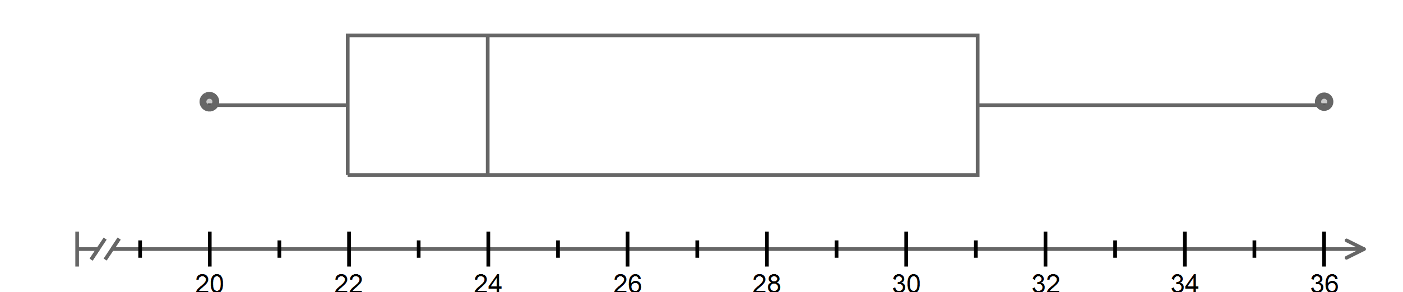

**(a**) What is the maximum and minimum number of weeks for construction?

**(b)** What is the interquartile range of the data?

**(c)** From the box plot, which term could be used to describe the data?

**i.** bimodal **ii.** normal **iii.** skewed **iv.** Symmetrical

**(d)** Which of these statements is true?

**i.** 25% of projects took less than 31 weeks. **ii.** 75% of projects took more than 31 weeks.

**iii.** 25% of projects took more than 22 weeks. **iv**. 75% of projects took more than 22 weeks.

**~ END OF TEST SECTION 1 ~**

|  |  |  |  |  |
| --- | --- | --- | --- | --- |
| Name: | \_\_\_\_\_\_\_\_\_\_\_\_\_\_\_\_\_\_\_\_\_\_\_\_\_\_\_\_\_\_\_\_\_\_\_\_\_\_\_\_\_\_\_\_\_\_\_\_\_\_\_ | | | Date: *\_\_\_\_\_\_\_\_\_\_\_* |
| **SECTION 2: CALCULATOR ASSUMED** | | | | |
| **Time:** | *35 minutes* | **Marks for Section 2:** | *30* | |
| **Reading:** | *3 minutes* | **Equipment Allowed:** | *1 page notes (A4 one side),*  *CAS calculator* | |
| **Working:** | *32**minutes* |  |  | |

|  |  |
| --- | --- |
| **6.** | **[8 marks: 3, 1, 2, 2]** |

The strike rates (runs per 100 balls) of cricketers playing in a one-day cricket competition are;

39, 42, 31, 70, 63, 59, 85, 54, 61, 60, 69, 61, 54, 56, 63, 95, 81, 67,  88, 6

**(a)** Construct a boxplot for the data (Hint: Use your Graphics or Scientific Calculator)

|  |  |  |  |  |  |  |  |  |  |  |  |  |  |  |  |  |  |  |  |  |  |  |  |  |  |  |  |  |  |  |  |  |  |  |  |  |
| --- | --- | --- | --- | --- | --- | --- | --- | --- | --- | --- | --- | --- | --- | --- | --- | --- | --- | --- | --- | --- | --- | --- | --- | --- | --- | --- | --- | --- | --- | --- | --- | --- | --- | --- | --- | --- |
| **(b)** Use the box plot to determine the interquartile range.  **(c)** Complete the following statements :  ‘The top 25% of the players had strike rates above \_\_\_\_\_\_\_\_\_\_\_\_ runs per100 balls.’    ‘Fifty per cent of players had strike rates less than \_\_\_\_\_\_\_\_\_\_\_\_\_\_\_runs per100 balls.’  **(d)** Use the box plot to describe the distribution of strike rates in terms of shape, center, spread and outliers.  **7. [3 marks: 1 mark each]**  The following data represent the weights (in grams) of a simple random sample of 50 M&M  plain chocolates;   |  |  | | --- | --- | | **Weight** | **Frequency** | | **0.79** | **1** | | **0.80** | **0** | | **0.81** | **1** | | **0.82** | **2** | | **0.83** | **2** | | **0.84** | **6** | | **0.85** | **2** | | **0.86** | **6** | | **0.87** | **5** | | **0.88** | **7** | | **0.89** | **3** | | **0.90** | **4** | | **0.91** | **5** | | **0.92** | **1** | | **0.93** | **3** | | **0.94** | **1** | | **0.95** | **1** |   *Source*: Michael Sullivan  **(a)** Calculate the mean weight for the M&M’s  **(b)** Calculate the median weight for the M&M’s  **(c)** Determine the shape of the distribution of weights based on this sample |

**8. [3 marks; 2, 1]**

Consider these two frequency histograms.

B



**(a)** Calculate the means of A and B.

**(b)** Compare, without calculation, the standard deviations of A and B.

|  |  |
| --- | --- |
| **9.** | **[5 marks: 2, 2]** |

The following data represents the ages of people who attended a seminar on “Coping with a digital future”.

1. 62 34 28 60 46 57 65 54 43 29 15 35 29 32 43 48 51 50 53

68 61 64 34 31 43 46 51 57 65 62 31 47 43 59 57 60 54 67 65

**(a)** Complete the following frequency table for the above data

|  |  |  |
| --- | --- | --- |
| Age | Tally | Frequency  *(f)* |
| 10-19 |  |  |
| 20-29 |  |  |
|  |  |  |
|  |  |  |
|  |  |  |
|  |  |  |
|  | Total |  |

**(b)** Construct a histogram to represent the data.

**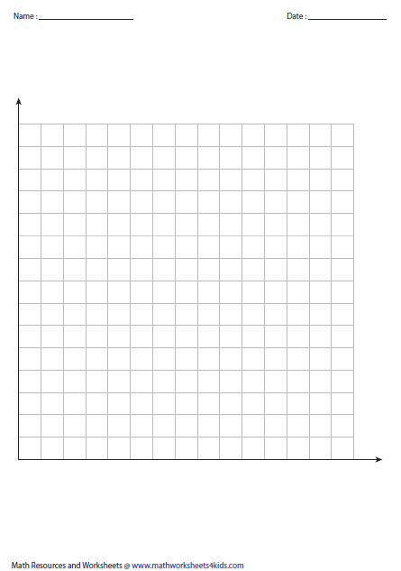**

|  |  |
| --- | --- |
| **10.** | **[12 marks: 2, 5, 2, 3]** |

Use the table below to calculate the following questions;

|  |  |  |  |  |  |  |  |  |  |  |  |  |  |  |
| --- | --- | --- | --- | --- | --- | --- | --- | --- | --- | --- | --- | --- | --- | --- |
| **Student** | **A** | **B** | **C** | **D** | **E** | **F** | **G** | **H** | **I** | **J** | **K** | **L** | **M** | **N** |
| **Coursework mark** | **27** | **44** | **39** | **23** | **41** | **48** | **37** | **34** | **40** | **43** | **30** | **43** | **29** | **27** |
| **Examination mark** | **12** | **47** | **26** | **25** | **38** | **45** | **35** | **35** | **41** | **39** | **32** | **25** | **18** | **30** |

**(a)** Calculate the range for both Coursework mark and examination marks.

**(b)** Construct a back to back stem and leaf plot for this data.

**(c)** Calculate the mean scores for both sets of data.

**(d)** Using measures of central tendency and spread what conclusions can you make in comparing the coursework marks to the exam marks for these students?

**~ END OF TEST SECTION 2 ~**